
American International University- Bangladesh
Faculty of Engineering (EEE)
Electronic Devices Laboratory

Title: Determination of Characteristic Curve of a Diode

Abstract:

A diode is one of the simplest electronic devices. It is a unidirectional device. A diode does not behave linearly with respect to applied voltage and has an exponential I-V relationship. There are two operating regions for the diode, reverse biased region, and forward biased region. The diode is simply a semiconductor pn junction. In addition to being applied as a diode, the pn junction is the basic element of bipolar-junction transistors (BJTs) and field-effect transistors (FETs).

Introduction:

The objectives of the Experiment 1 of the Electronic Devices Lab are,
- To become familiar with semiconductor diode.
- To determine the characteristic curve of a semiconductor diode.

Theoretical Background:

Diode Structure
The semiconductor diode is created by simply joining an n-type and a p-type material together [1]. It is a pn junction as shown in Figure 1. As indicated, the pn junction consists of p-type semiconductor material in contact with n-type semiconductor material. A variety of semiconductor materials can be used to form pn junctions like silicon, germanium, gallium arsenide etc. However, we will concentrate on silicon, as this is the most widely used material in microelectronics. In actual practice, both the p and n regions are part of the same silicon crystal. The pn junction is formed by creating regions of different doping (p and n regions) within a single piece of silicon. The material is doped by bringing in additional atoms (impurities). The impurities can be either donors or acceptors atoms. The words acceptor and donor can be associated with donating and accepting electrons.
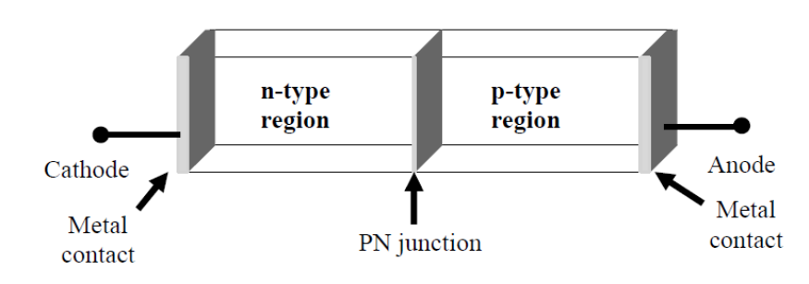
Figure 1: pn junction diode structure
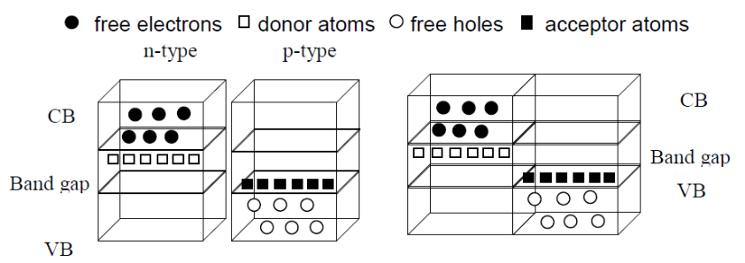
Figure 2: a) separate pieces b) pn junction

PN Junction
To understand how a pn junction is formed we will start by imagining two separate pieces of semiconductor, one n-type and the other p-type as shown in Figure 2(a). Now we bring the two pieces together to make one piece of semiconductor. This results in the formation of a pn junction (Figure 2(b)).

Forward/Reverse Bias Characteristics
If a negative voltage is applied to the pn junction, the diode is in reverse biased. In response, free holes and electrons are pulled towards the end of the crystal and away from the junction. The result is that all available carriers are attracted away from the junction, and the depletion region is extended. There is no current flow through under such conditions. If the applied voltage is positive, the diode operates in forward bias. This has the effect of shrinking the depletion region. Now, electrons in the p-type end are attracted to the positive applied voltage, while holes in the n-type end are attracted to the negative applied voltage.

Diode Characteristics
In forward bias condition, a cut-in voltage has to be overcome for the diode to start conduction. In silicon, this voltage is about 0.7 volts. In reverse-bias condition, the current is limited to IS (reverse saturation current). For higher value of reverse voltages, the junction breaks down. Figure 3 shows the diode I-V characteristics.
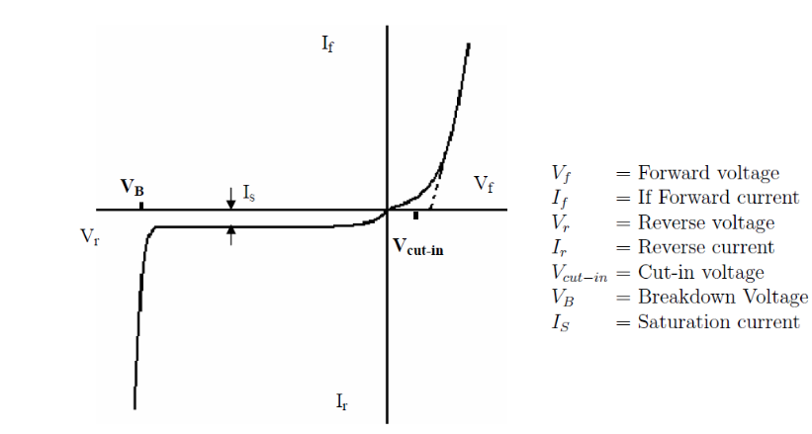
Figure 3: Diode IV Characteristics

Apparatus:

No. | Apparatus | Quantity
1 | Diode | 1
2 | 10 K Resistance | 1
3 | Project Board | 1
4 | DC Power Supply | 1
5 | Multimeter | 1

Circuit Diagram:
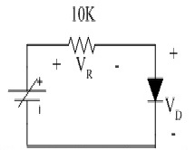
Figure 4: Circuit diagram for determining diode characteristic

Safety Precaution:
The following is a list of some of the special safety precautions that should be taken into consideration when working with diodes:
- Never remove or insert a diode into a circuit with voltage applied.
- When testing a diode, ensure that the test voltage does not exceed the diode's maximum allowable voltage.
3. Ensure a replacement diode into a circuit is in the correct direction.

Pre-lab Homework:
Implement the circuit (Figure 4) using LTSpice or Multisim. Some other diodes can also be used such as 1N914 or 1N4001. Measure the values of different parameters and fill up the table (Table 1) using the simulation tool.

Experimental Procedure:

- Measure the actual value of the 10K resistor.
- Connect the components except the power supply as shown in the figure.
- Turn on the DC power supply and measure the voltage across its two terminals and fix it at 0V. Now turn off the power supply.
- Connect the power supply in the circuit and turn it on. Remember that before powering up, the power control knob should be at minimum position.
- Vary the supply voltage in a 0.5V step and measure the voltage across the Diode V_{D} and the voltage across the resistor and record the result in the table.

Table 1: Data Table for Diode characteristic:
V_{in} | V_{D} | V_{R} | I_{d} = V_{R}/(R)
- Calculate I_{d} and fill up the table above.
- Plot the V_{D} vs I_{d} characteristic curve for the diode.
- Determine the “knee voltage”

Report:

- Plot the V_{D} - I_{d} characteristic curve for the diode and comment on the result.
- What will happen if the supply voltage polarity is reversed for the case of using a diode with PIV of 4.8V?
- Discuss the overall experiment as a whole.

References:

- Robert L. Boylestad, Louis Nashelsky, Electronic Devices and Circuit Theory, Ninth Edition, 2007-2008
- Adel S. Sedra, Kennth C. Smith, Microelectronic Circuits, Saunders College Publishing, 3rd ed., ISBN: 0-03-051648-X, 1991.
- American International University–Bangladesh (AIUB) Electronic Devices Lab Manual.
- David J. Comer, Donald T. Comer, Fundamentals of Electronic Circuit Design,
john Wiley & Sons Canada, Ltd.; ISBN: 0471410160, 2002.

